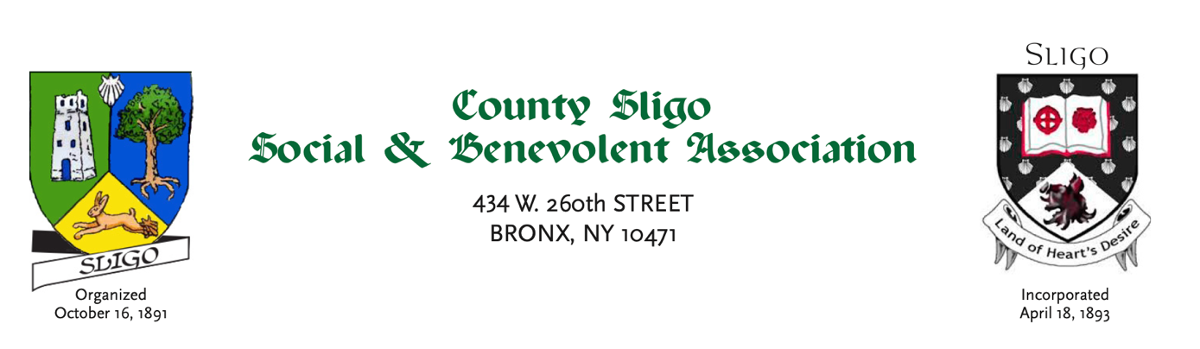

MEMBERSHIP APPLICATION
Membership shall be restricted to natives of County Sligo, members of their immediate families or their descendants.
Understanding that the objects of this association are: To promote unity and goodwill amongst its members and to spread Sligo’s rich cultural history and traditions amongst a new generation of Sligo people, the undersigned, in applying for membership, promises to abide by the constitution and by-laws of The County Sligo Social & Benevolent Association of New York.

Name(s): Address: Email: Native/Descendant of:

Make check or money order for $27 payable to:
County Sligo Social & Benevolent Association of New York, Inc. Mail to: 434 West 260th Street, Riverdale, NY 10471.

